R &D Challenge

Install Docker on AWS EC2
Step 1: launch EC2 instance
Step2: connect to instance
Step3: install docker by below command
Sudo yum install docker
Step4: start and check status of docker whether it is running or not
Sudo systemctl start docker
Sudo systemctl status docker

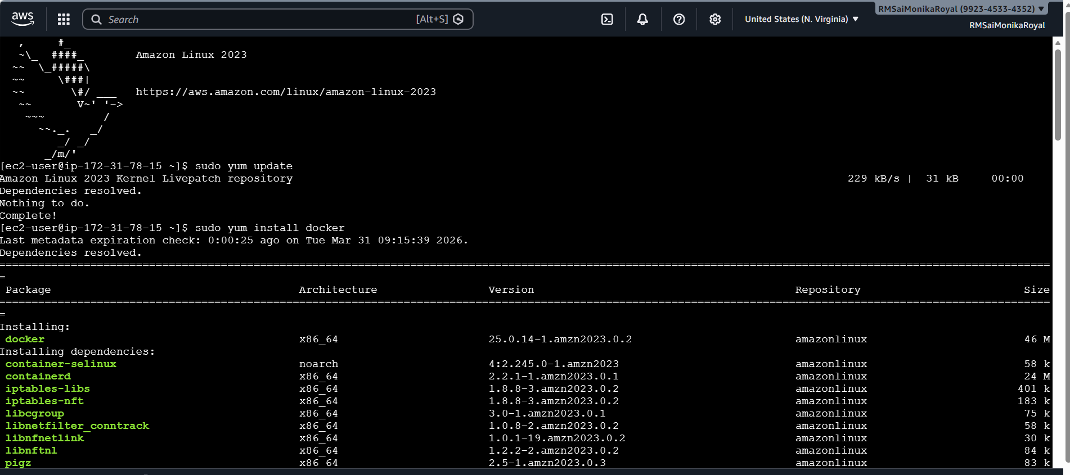

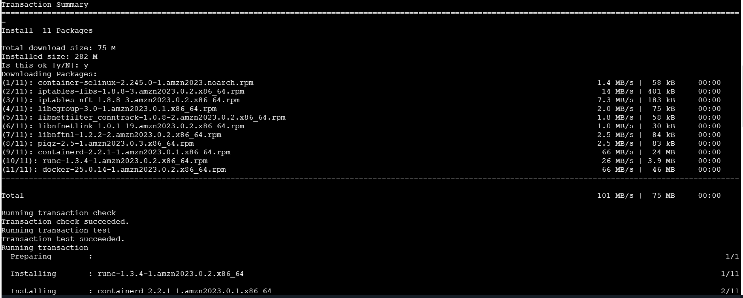

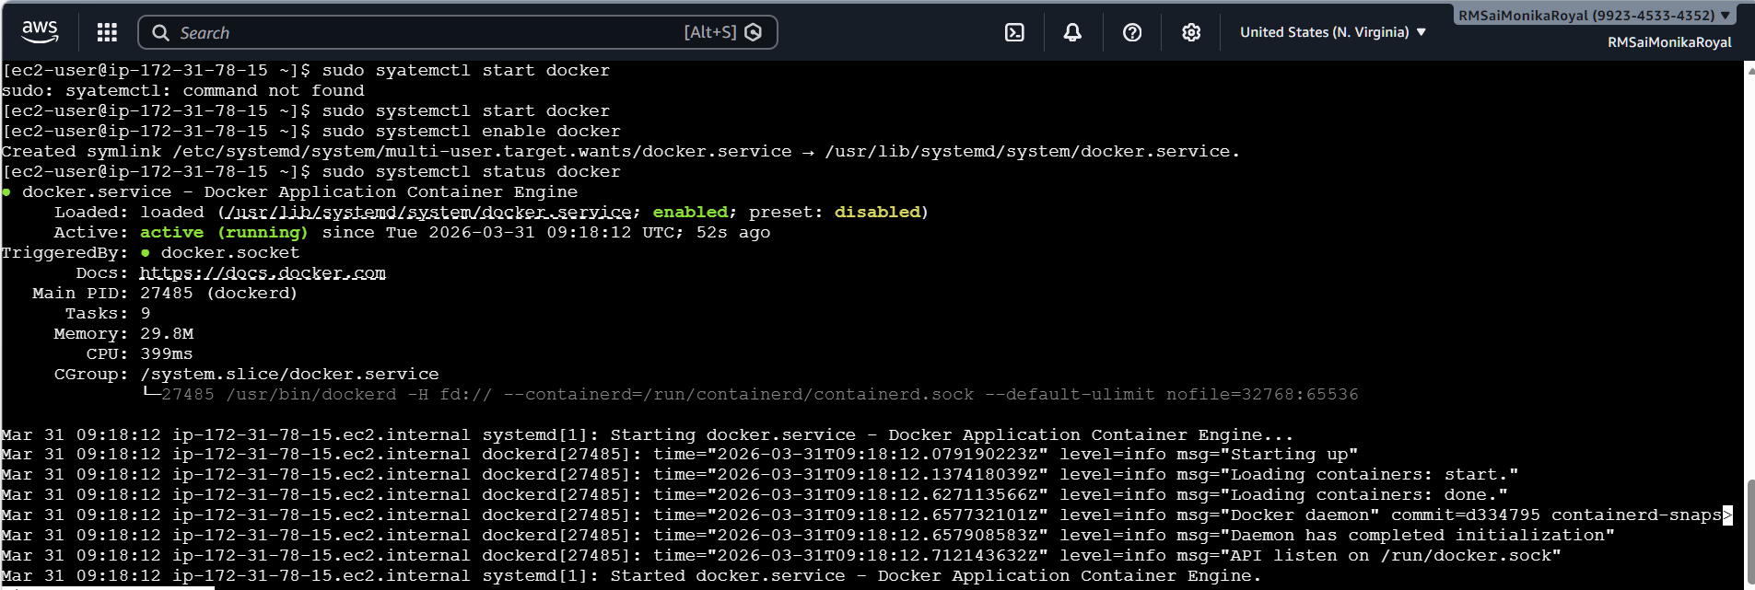

2. Install httpd
Sudo yum install httpd – Install apche
Sudo systemctl start httpd
Sudo systemctl enable httpd
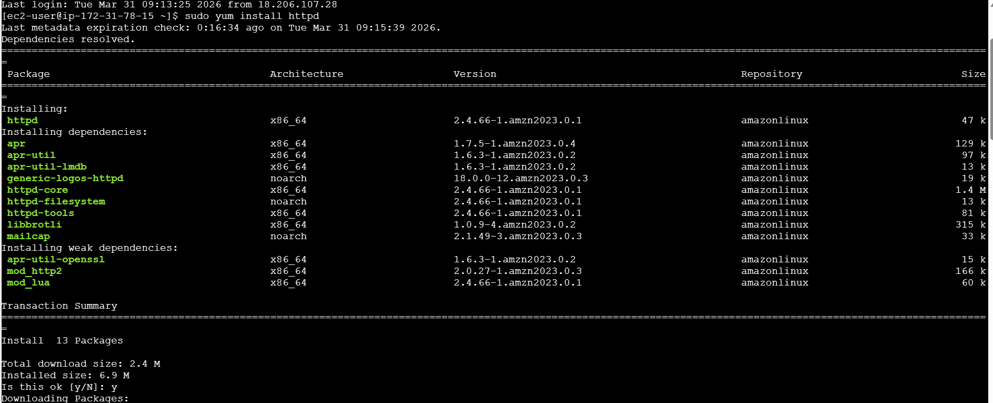
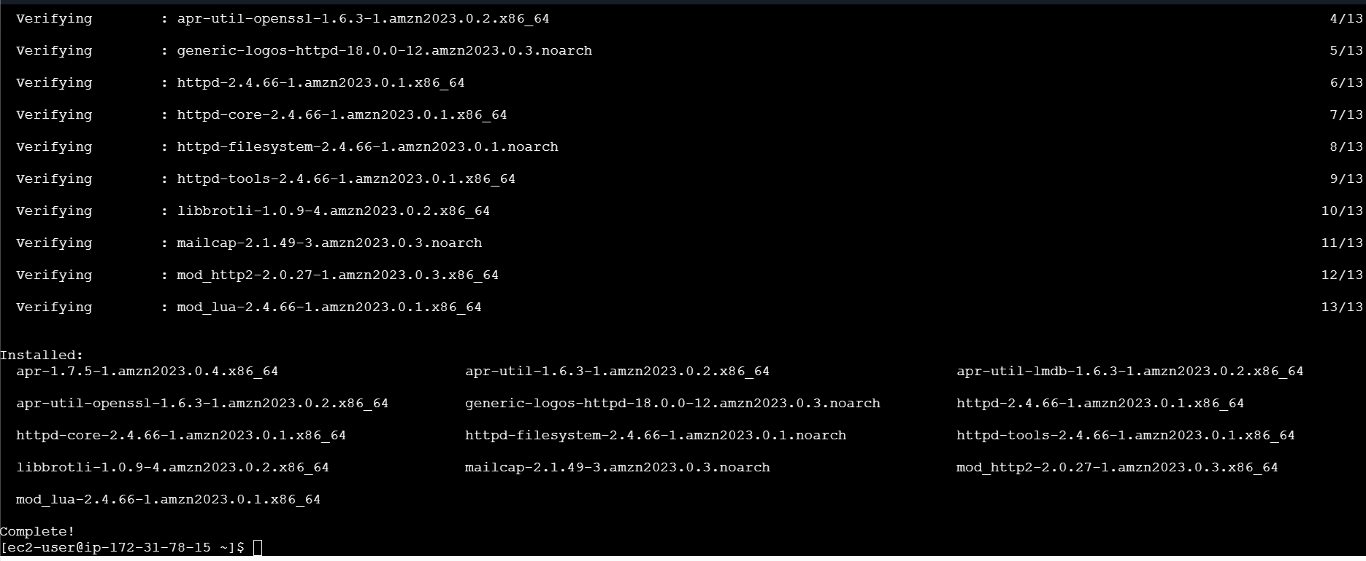

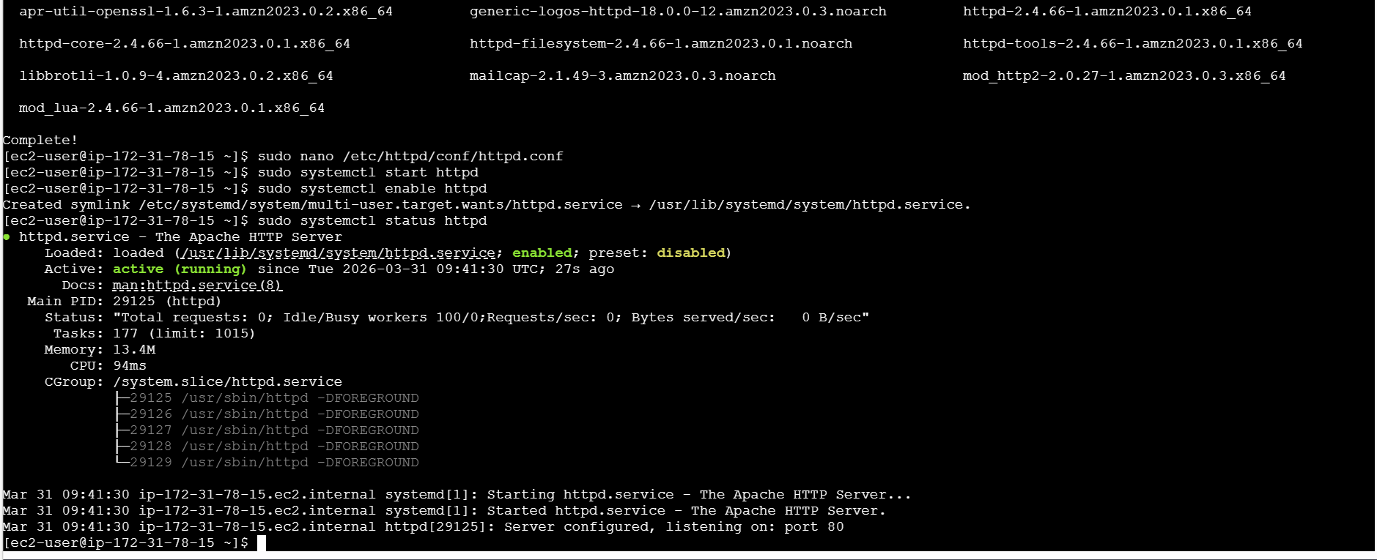
3.Install Jenkins
First I have installed java
Added Jenkins repositories
Imported Jenkins key
Installed Jenkins
Configured security group, I have added port number 8080
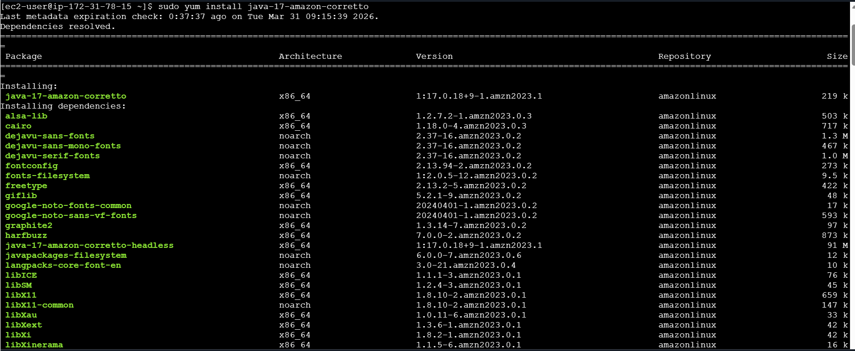
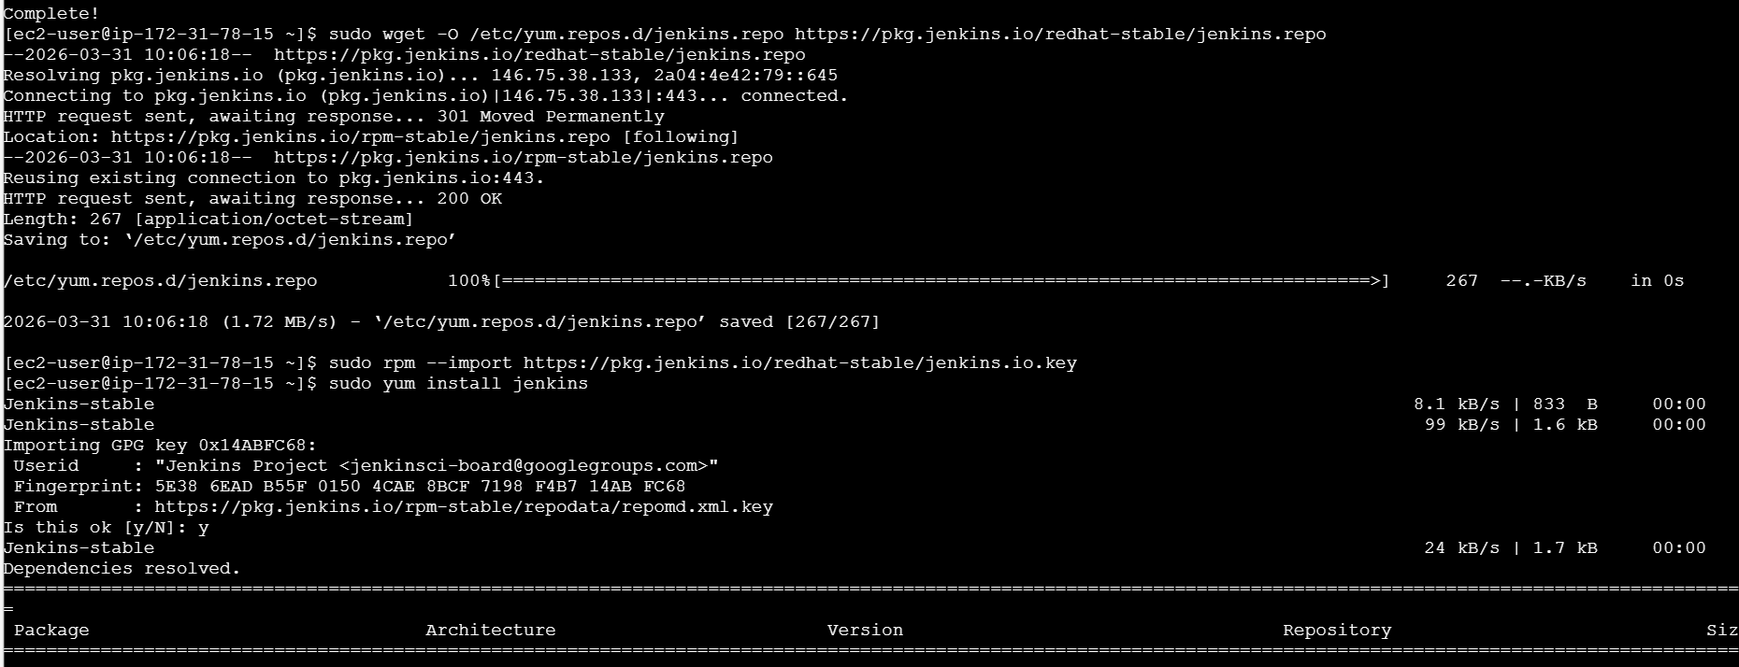
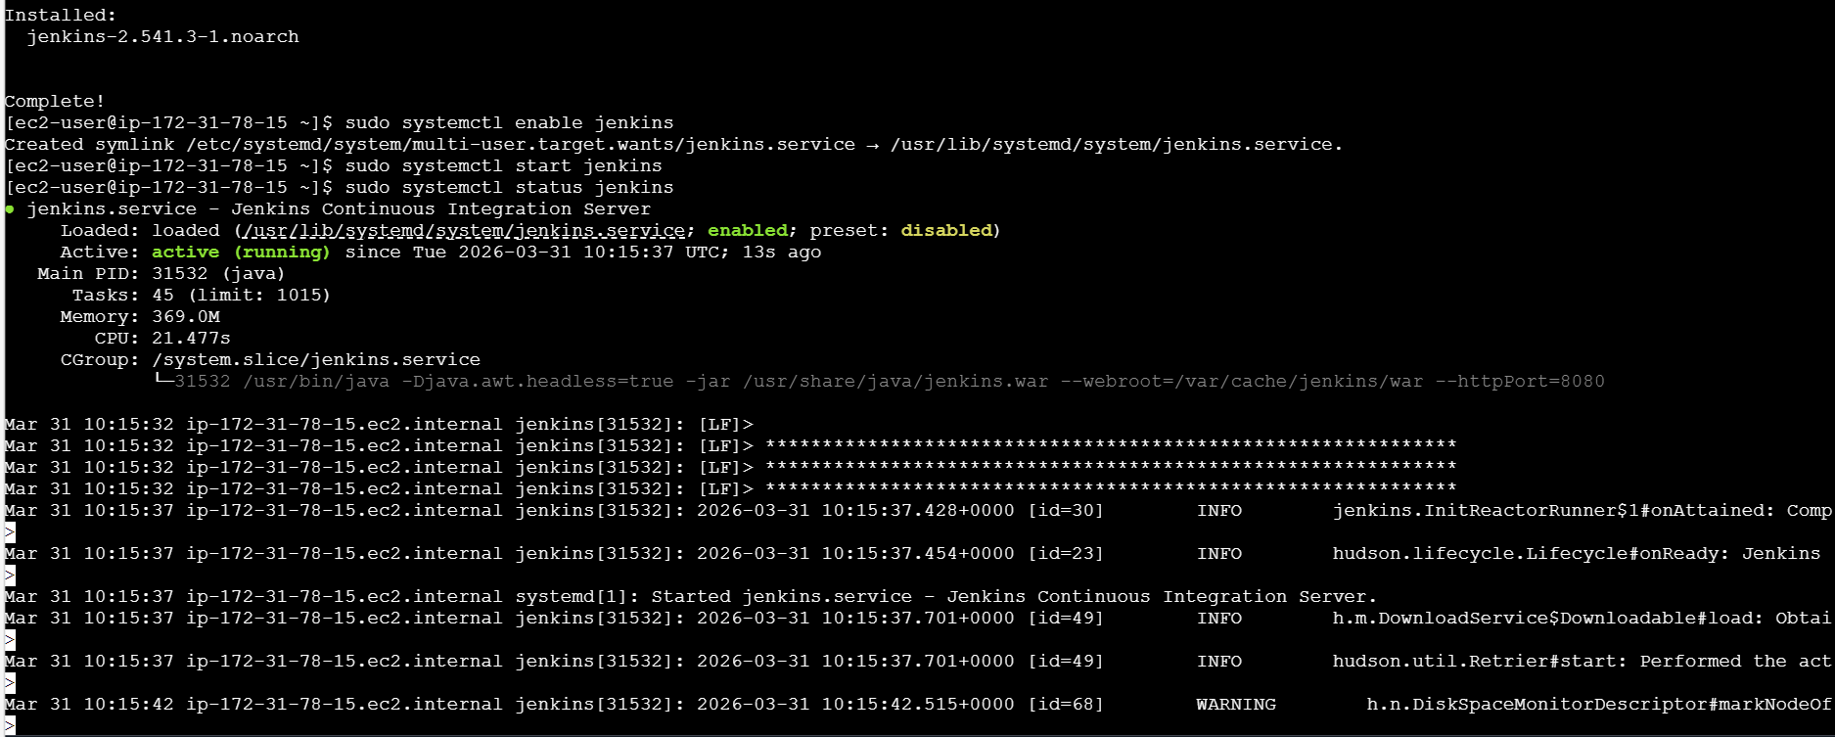
4.Install nginx
I have installed nginx
Started nginx service
I have checked the status whether it is active or running
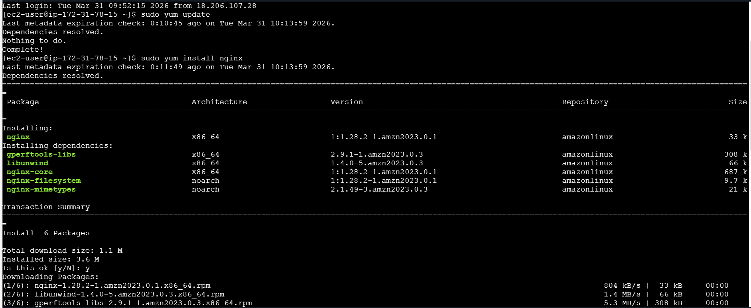
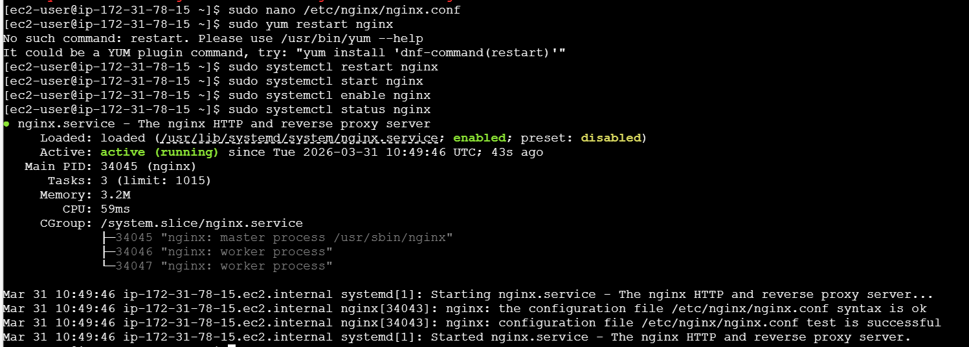

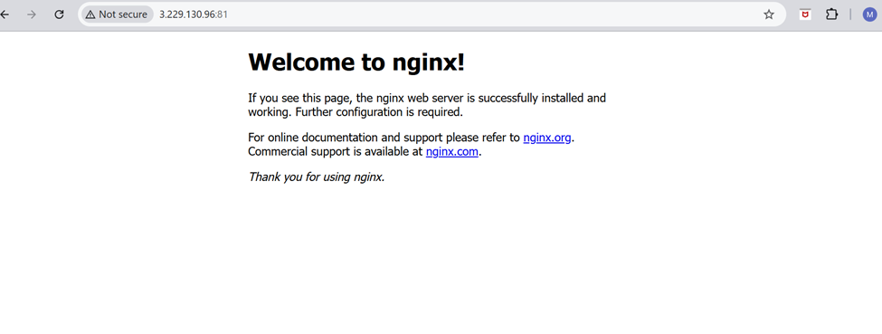
5.Apache tomcat
First I have downloaded the package from browser and installed by wget command
I have extracted the downloaded tar file.
I gave the port number as 8081
